Name:P.Gayathri
Reg.No:192424324

14. Write the Python Program to Implement Alpha-Beta Pruning Algorithm for Gaming
Aim:
To implement the Alpha-Beta Pruning Algorithm, which improves the Minimax algorithm by eliminating branches that do not affect the final decision, thereby reducing the number of nodes evaluated.

Algorithm:
Step 1:
Define the game tree with terminal node values.
Step 2:
Initialize Alpha = -∞ and Beta = +∞.
Step 3:
If it is MAX's turn, choose the maximum value and update Alpha.
Step 4:
If it is MIN's turn, choose the minimum value and update Beta.
Step 5:
If Alpha ≥ Beta, stop exploring the remaining child nodes (Pruning).
Step 6:
Continue until all necessary nodes are evaluated.
Step 7:
Display the optimal value.
PROGRAM:

# Alpha-Beta Pruning Algorithm for Gaming

def alphabeta(depth, node, alpha, beta, maximizing_player, values):

# Leaf node
if depth == 3:
print(" " * depth + "Value =", values[node])
return values[node]

if maximizing_player:
best = float('-inf')

for i in range(2):
child = node * 2 + i

value = alphabeta(
depth + 1,
child,
alpha,
beta,
False,
values
)

best = max(best, value)
alpha = max(alpha, best)

# Beta cut-off
if beta <= alpha:
print(" " * (depth + 1) +
"PRUNED")
break

return best

else:
best = float('inf')

for i in range(2):
child = node * 2 + i

value = alphabeta(
depth + 1,
child,
alpha,
beta,
True,
values
)

best = min(best, value)
beta = min(beta, best)

# Alpha cut-off
if beta <= alpha:
print(" " * (depth + 1) +
"PRUNED")
break

return best

# Leaf node values
values = [3, 5, 2, 9, 12, 5, 23, 23]

# Initial values
alpha = float('-inf')
beta = float('inf')

print()
print("ALPHA-BETA PRUNING SEARCH TREE")
print("================================")
print()

print(" MAX")
print(" / \\")
print(" MIN MIN")
print(" / \\ / \\")
print(" MAX MAX MAX MAX")
print(" / \\ / \\ / \\ / \\")
print(" 3 5 2 9 12 5 23 23")

print()
print("Evaluating Tree...")
print()

result = alphabeta(
0,
0,
alpha,
beta,
True,
values
)

print()
print("================================")
print("ALPHA-BETA RESULT")
print("================================")
print("Optimal Value =", result)

OUTPUT:
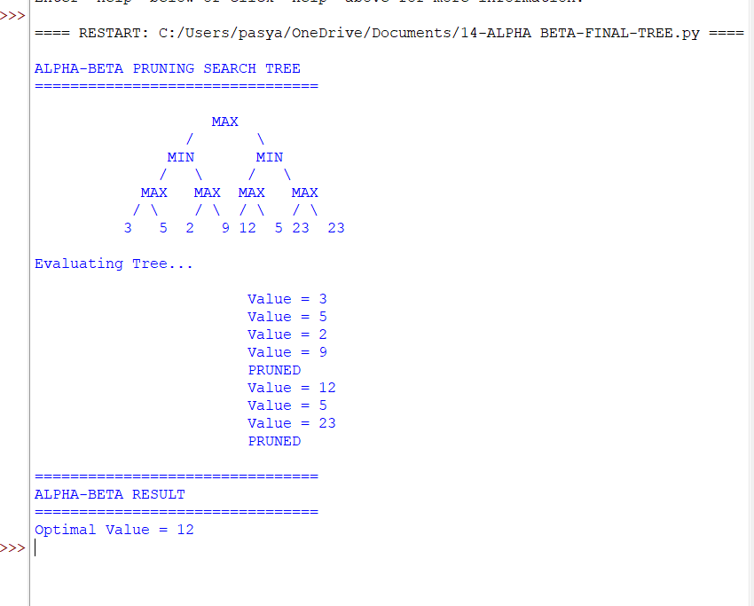

RESULT:
Thus, the Alpha-Beta Pruning Algorithm was implemented successfully in Python, and the optimal game value was obtained while reducing unnecessary node evaluations through pruning.

